The Corona CURE in a nutshell
The ongoing COVID-19 pandemic is caused by SARS-CoV-2, a coronavirus that emerged towards the end of 2019. While some coronaviruses are the cause of the common cold (e.g. HKU1 and OC43), others cause more severe illness with varying success and mortality rates (e.g. MERS, SARS-CoV, SARS-CoV-2; Figure 1).
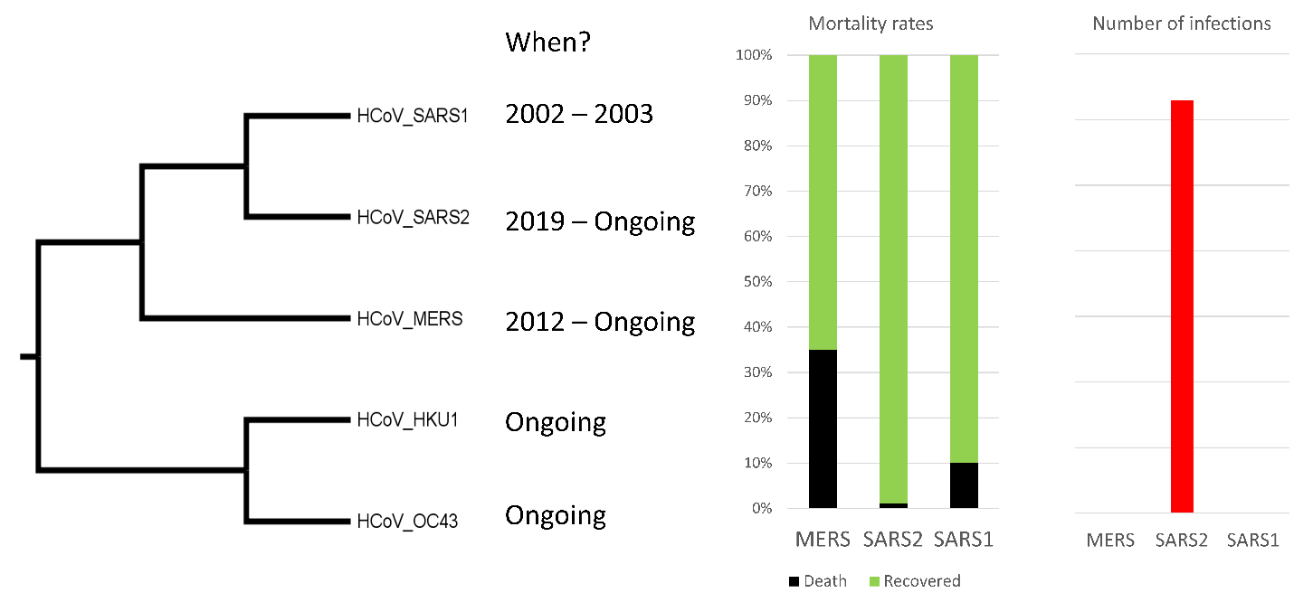
Figure 1. In 2002-2003, the SARS-CoV (SARS1) outbreak resulted in about 8,000 cases with a mortality rate of 10%. Fortunately, the SARS-CoV epidemic was short-lived. In 2012, the MERS-CoV outbreak began. This epidemic is ongoing, but geographically limited to the Middle East where it spreads from camel-to-camel and camel-to-human. There have been about 2,600 known cases of MERS-CoV with a mortality rate of ~35%. SARS-CoV-2 (SARS2), the cause of the ongoing COVID-19 pandemic, is the most infectious among these coronaviruses. As of October 30, 2022, SARS-CoV-2 has caused >630 million known infections with a global death toll surpassing 6.5 million humans.
Researchers across the globe have developed vaccines for COVID-19 and vaccination efforts are underway. However, novel mutations are part of the process of evolution, and new variants, like Delta and Omicron, are cause for concern. Not only may the variants spread faster, the protection from the developed vaccines and previous infection is affected.
Your mission in this research unit is to
- investigate where in the SARS-CoV-2 proteins the mutations for different variants are located
- use an evolutionary study to propose drug and vaccine targets for SARS-CoV-2 and its current and future variants as well as for other coronaviruses such as MERS-CoV.

The Corona research experience in a nutshell
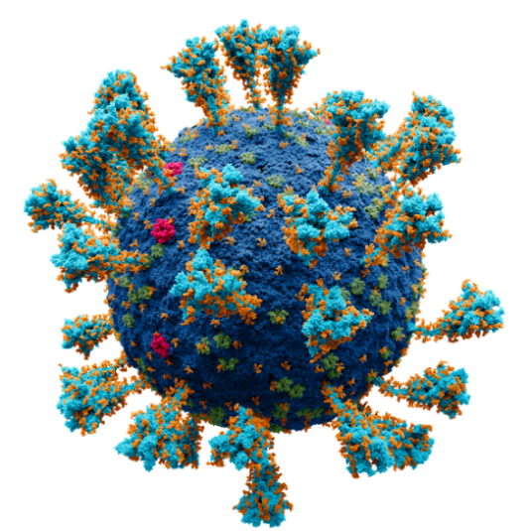
You will investigate two proteins:
- Spike, the tulip-like protein, anchored to the outside of the coronavirus capsule (Figure 2). Spike is one of the most antigenic proteins in a COVID-19 infection and the main component of COVID-19 vaccines. Spike enables the virus to enter a human cell by attaching to a human cell receptor.

- RNA-dependent RNA polymerase (RdRP) replicates the virus genome. Antiviral drugs for many viruses target RdRPs. RdRP is also called Non-Structural Protein 12 or NSP12. Coronaviruses are RNA viruses and RdRP is critical for making new viruses.
Figure 2. A model of SARS-CoV-2 with the Spike protein shown in light blue with post-translational modifications (glycosylation) in orange.

First, you will explore how these two proteins have evolved across betacoronaviruses and how the SARS-CoV-2 variants are evolving today.
Evolution across betacoronaviruses
For this lesson, you will be working in pairs. One person will work with Spike, and the other with RdRP.
Check the protein you have been assigned: ☐ Spike ☐ RdRP
Step 1: Import unaligned (raw) sequence data
- Typically, you would have to find the sequence data from a database or experiment first, but we have compiled a dataset for Spike and a dataset for RdRP for you. The datasets have sequences from the same viruses.
- Copy this link for Spike: https://13210fe9-5650-9cb6-d1f6-5ed577b033a0.filesusr.com/ugd/1cb982_eff879025eac4690b5e5c28e57b55a15.txt?dn=spike_14.fasta.txt
- Copy this link for RdRP: https://13210fe9-5650-9cb6-d1f6-5ed577b033a0.filesusr.com/ugd/1cb982_08e0c445dd1a46a9a6db13cb7e2ee93a.txt?dn=NSP12_14.fasta.txt

- You will use Wasabi to work with your sequence data. Wasabi is an online graphical environment for evolutionary sequence analysis. Go to http://was.bi/.

- Click on the document icon on the upper left and select Import:
- Paste the link you copied under a. into the last box (Import from other sources) and click Import:

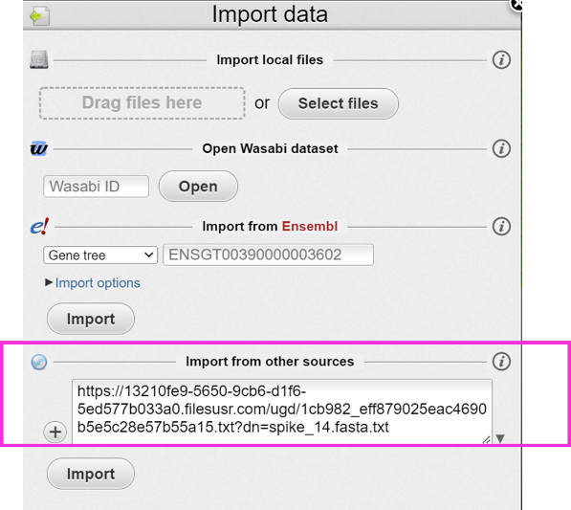

This imports the sequence data into Wasabi. You can make the width of the field that shows the sequence names on the left side wider, and you can move the names using the dial above the sequence names. All sequences with names that start with HCoV are human infecting coronaviruses. In addition to the three coronaviruses mentioned above, HCoV_OC43 and HCoV_HKU1 which cause mild cold-like symptoms are included in the dataset. Sequences that start with BCoV or TBCoV are bat infecting coronaviruses. You may have heard that bats are a large reservoir of viruses and the available sequence data reflects that. The remaining sequences are named by their host.

- For each species on the left there is a sequence. What type of macromolecule (DNA or protein) does this sequence data represent? How do you know this?

Answer: Click or tap here to enter text.

- If the sequence was the other type of macromolecule, how would it look?

Answer: Click or tap here to enter text.

- As you can see there are lots of letters, each sequence is shown by its one letter abbreviation, and they are colored similarly if they have similar properties. Do you think all sequences are the same length? Scroll to the end to find out. Do all sequences end at the same point? Which sequence is the shortest and which is the longest? How long is the sequence for SARS2?

Answer: Click or tap here to enter text.

- You have now imported and viewed “raw” sequence data in the sense that the data is not aligned. Sequences evolve not just by mutation but also through insertion and deletion events. To be able to compare what changes have occurred in the proteins, we need to line them up so that columns with equivalent sites (that share ancestry and thus have an evolutionary signal) can be formed (Figure 3).
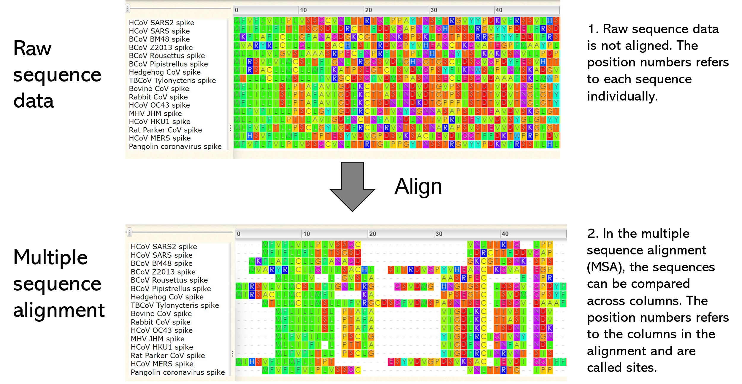
Figure 3. The upper part shows the unaligned sequence data and the lower shows aligned sequence data (example only, not exactly the same as your data). For the multiple sequence alignment, each column has amino acids that share common ancestry. In different columns, you may notice vertical patterns of certain amino acids – some may be conserved for one specific amino acid all throughout, some may have a specific set of amino acids (ex. L, M, F), and others may be so variable that they have no pattern at all.
Step 2: Import the aligned sequence data for the same sequences
- Copy this link for Spike: https://13210fe9-5650-9cb6-d1f6-5ed577b033a0.filesusr.com/ugd/1cb982_014e070daaf240e08617c08141475b09.txt?dn=spike_14_msa.fa.txt
Copy this link for RdRP: https://13210fe9-5650-9cb6-d1f6-5ed577b033a0.filesusr.com/ugd/1cb982_d55916d627b94233b4eb2b2b6ec5eae5.txt?dn=NSP12_14_msa.fa.txt

- Click on the document icon on the upper left and select Import:

- Paste the link into the last box (Import from other sources), like you did for the unaligned sequence data, and click Import.

- In the aligned sequences, gaps (shown as dashes ‘-‘) in one sequence means that at least one other sequence in the alignment has additional sequence in this position (but it does not mean that the sequence is incomplete unless it is at the beginning or the end). Missing characters within amino acid sequences are shown as X.

- Use the scroll bar on the bottom of the sequence alignment to scroll to the end of the alignment. Do all sequences end in the same point? Keep in mind that gaps (-) count as characters in an alignment.

Answer: Click or tap here to enter text.

- What is the length of the alignment? How does that compare to the length of the SARS2 sequence for your protein?

Answer: Click or tap here to enter text.

- Scroll through the alignment. What kind of patterns do you see? Are there columns that are not changing in amino acid (conserved) and others that do change in amino acid (variable)?

Answer: Click or tap here to enter text.

- Compare multiple sequence alignments with your partner. Which protein do you think is evolving faster? Why?

Answer: Click or tap here to enter text.

Step 3: Import the phylogenetic tree based on the aligned sequences
- Copy this link for Spike: https://13210fe9-5650-9cb6-d1f6-5ed577b033a0.filesusr.com/ugd/1cb982_4ae72e9066ab476f8398148fd474f0d5.txt?dn=Spike_tree_msa.txt
Copy this link for RdRP: https://13210fe9-5650-9cb6-d1f6-5ed577b033a0.filesusr.com/ugd/1cb982_7d822e79753949b6af359e5448774d93.txt?dn=RdRP_tree_msa.txt

- Click on the document icon on the upper left and select Import
- Paste the link into the last box (Import from other sources), like you did for the aligned sequence data, and click Import.
Step 4: Analyze the phylogenetic tree

Compare the Spike tree to the RdRP tree.

- What is the closest relative of SARS-CoV-2 based on these trees?
Answer: Click or tap here to enter text.

- Can you identify the SARS, MERS, and OC43 clades as shown in the figure above?
Answer: Click or tap here to enter text.

- Compare trees with your partner. Are the clades in agreement between the two trees? What differences/similarities do you observe in the clades and in the trees?
Answer: Click or tap here to enter text.

- Which of the two protein families (Spike or RdRP) is evolving faster? Hint: check the scale bar below the trees. If you “eye-ball” the alignment, does this seem correct?

Answer: Click or tap here to enter text.

- If we were to add the SARS-CoV-2 variants (alpha, beta, gamma, delta, omicron, and stealth omicron) to the dataset, redo the multiple sequence alignment and rebuild the tree, where in the Spike tree do you expect them to show up?

Answer: Click or tap here to enter text.

Step 5. Structural and evolutionary analysis
Different proteins evolve at different rates. Depending on the structure and function, some proteins can evolve faster without changing their function – most changes are neutral. Typically, some residues in proteins (or sites/columns in the alignment) are too important for function to change and we can observe these as conserved while others are able to change faster and we can observe these as not conserved (or variable).
Next, we will use the trees and alignments for your proteins to calculate the evolutionary rate for RdRP and Spike, respectively. The webserver for this step is ConSurf, where you can upload the alignment and tree that you generated above (but we have completed it for you, you will do it on your own later this week). ConSurf calculates rates based on the alignment while considering the tree topology for the sequences. The output includes the rates mapped to the alignment and to a protein structure. The color code is:
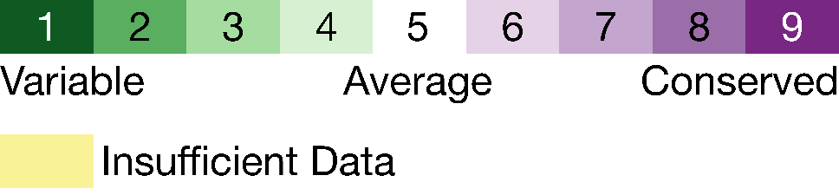
While the multiple sequence alignment shows the organization of the primary structure, proteins in the cell often adapt secondary structure such as alpha helices and beta strands, tertiary (3D) structure, and perhaps even quaternary structure where different 3D structures form a complex.
ConSurf maps the conservation scores onto the protein structure. We will use the protein structure viewer on ConSurf to explore the structures of both RdRP and Spike, and see how conservation is distributed across the protein’s surface.

First, we will all work together on RdRP
- To access the ConSurf colored structure for RdRP: https://consurf.tau.ac.il/ngl/viewer.php?job=1657717229&cbs=1

- RdRP will initially be colored by conservation, but let’s take a minute to orient ourselves in the structure first.

Use the panel on the right to change the Color option from ‘By Conservation’ to ‘By Secondary Structure’:

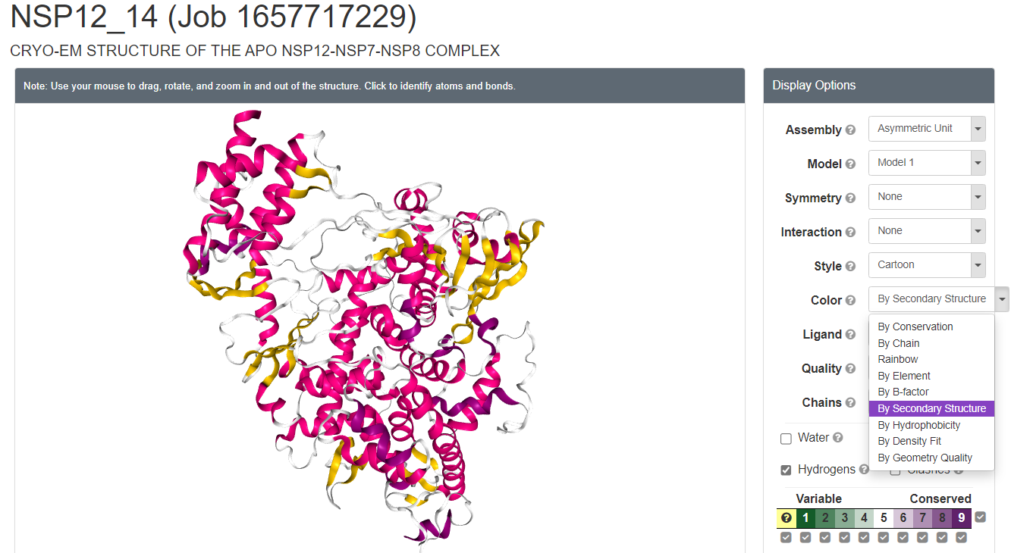

What color are alpha helices? Click or tap here to enter text.
What color are beta strands? Click or tap here to enter text.
What color are loops? Click or tap here to enter text.

- If you spin the protein around, try to find a “hole” in the protein’s structure. The “hole” makes up the active site of RdRP where the virus RNA genome is copied. Do you expect for the “hole” to be conserved or variable?

Answer: Click or tap here to enter text.

- On the right, change Color to ‘By Conservation’. Additionally change Style from ‘Cartoon’ to ‘Surface’. Ignore the yellow patches as they are not statistically significant (although biologically they may or may not be significant). Is the “hole” conserved or variable? What about the rest of the protein surface?

Answer: Click or tap here to enter text.

Now, we will all work together on Spike
- To access the ConSurf colored structure for Spike: https://consurf.tau.ac.il/ngl/viewer.php?job=1657720032&cbs=1

- Here, we must clean up a little before we can get into the structure. First, we will remove the small ligands that are glycosylations. Use the panel on the right to change the Ligand option from ‘Ball & Stick’ to ‘None’:
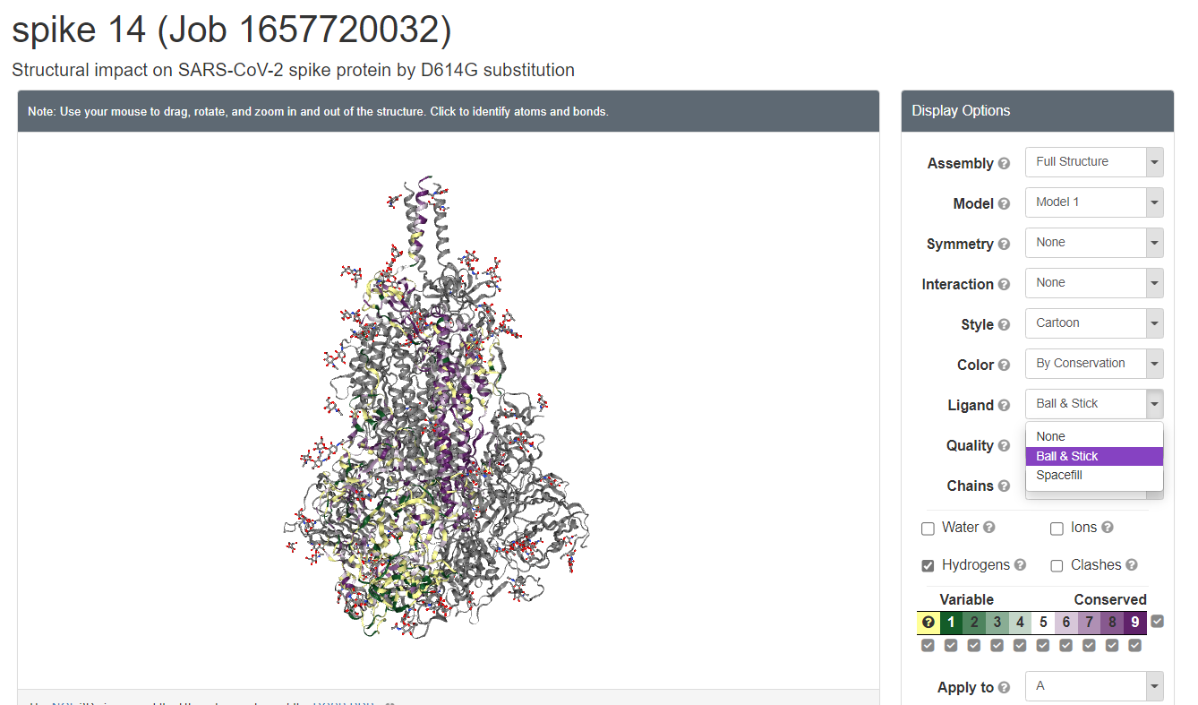

- Next, we will change the Style to ‘Surface’. Spike is a trimer, but two chains are colored grey and only one chain is colored by conservation. Spike has a lot of yellow sites which is due to it being rich in gaps.

- Orient Spike so that it looks similar to the figure on the right. Imagine that the table virus capsule where Spike is anchored (like in Figure 1).

How is the conservation distributed? (spin it around to get a better look).

Answer: Click or tap here to enter text.

- How does the conservation level vary between RdRP and Spike? Is one more conserved on the surface than the other? Why do you think that is? Consider the roles these proteins play and what parts may be important for their function.
Answer: Click or tap here to enter text.

Step 6. Applications – Leveraging protein structure and evolution for COVID-19 therapeutics
Consider the phylogenetic trees you and your colleagues built for the proteins. Plus, consider the pictures of Spike and RdRP below.
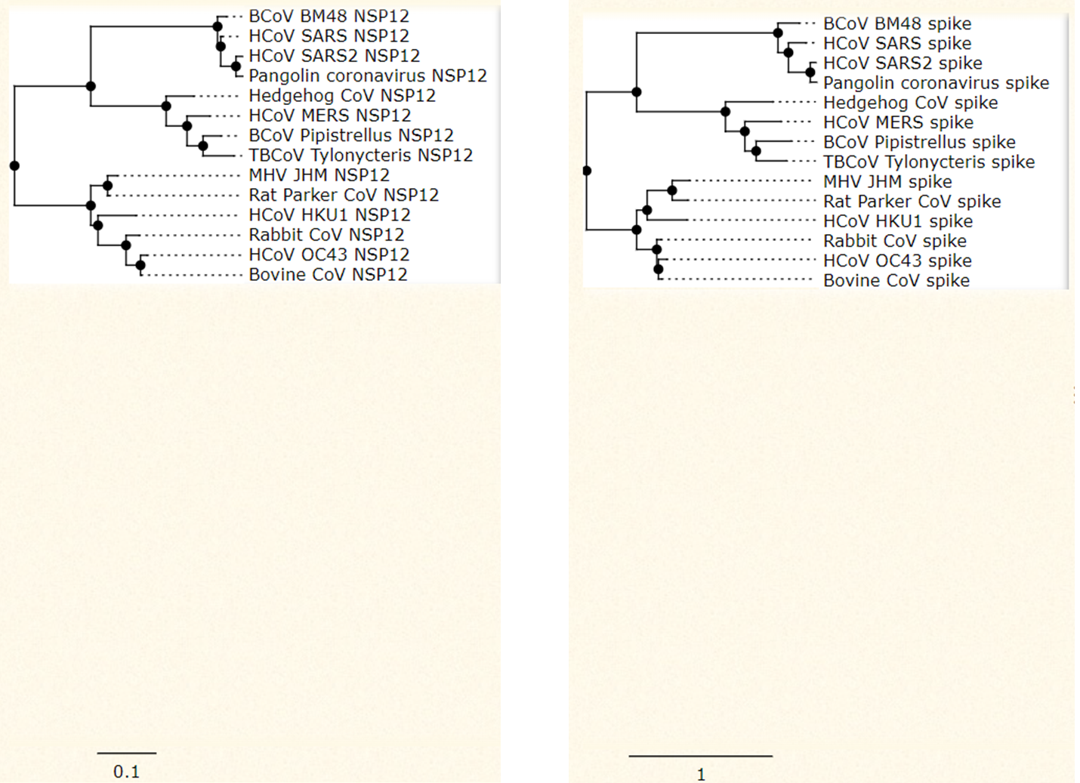
RdRP (NSP12) on the left and Spike on the right.
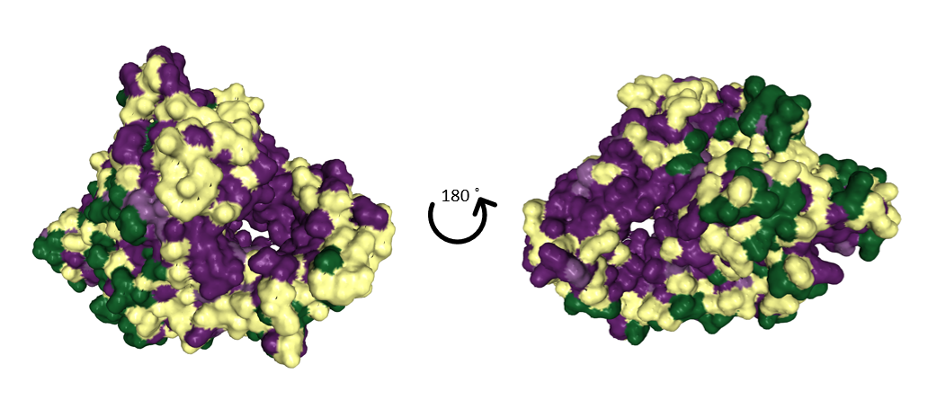
RdRP colored by conservation shown from front and back.

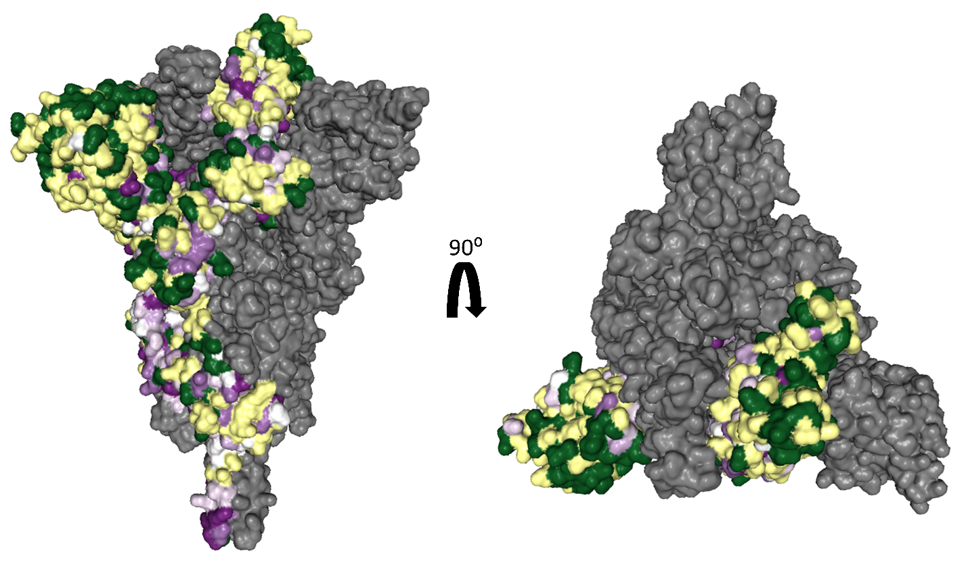

Spike colored by conservation (one chain only). On the left is a profile view of Spike and on the right is an overhead view of Spike.
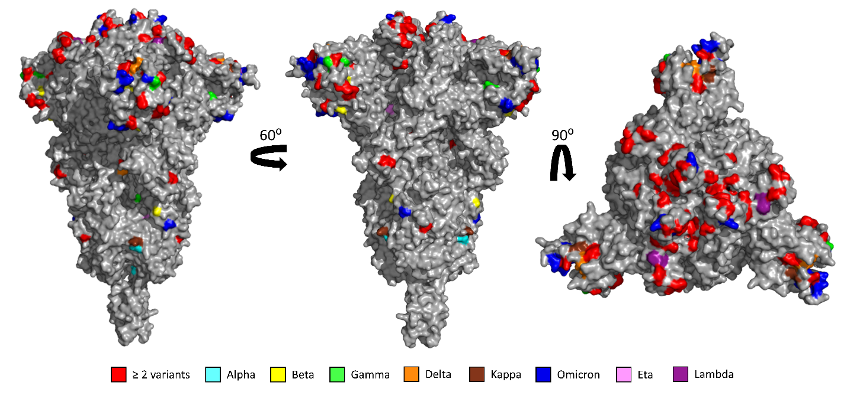

The SARS-CoV-2 variants often contain many mutations in Spike, while non-structural proteins like RdRP are usually less affected.

If you were tasked with coming up with the next vaccine or antiviral that would be broadly neutralizing (or pan-coronavirus) against SARS-CoV-2 and its current and future variants, which protein would you target? Explain your reasoning.

Answer: Click or tap here to enter text.

